

School of Computing Science and Engineering

Bachelor of Technology in Computing Science and Engineering (IoT, Cybersecurity and Blockchain Technology)

Course Code: B22EF0406 |  | Microcontroller and IoT Lab Project Report | Academic Year:2024-2025
 |  |  | Semester & Batch:4th Sem IoT ‘A’ sec A1 Batch
Project Details:
Project Title: | Rain Detection System using Arduino
Place of Project: | REVA UNIVERSITY, BENGALURU
Student Details:
Name: | Ashik Hebbar |  | Sign:
Mobile No: | 8150839959
Email-ID: | ugcet2300265@reva.edu.in
SRN: | R23EI008
Guide and Lab Faculty Members Details
Guide Name:  (The Faculty  Member Assigned) | Dr. Kumar Raja |  | Sign: Date:
Grade by Guide:
Name of Lab Co-Faculty 1 | Prof. G C Sathish |  | Sign: Date:
Name of Lab Co- Faculty 2 | Dr. Argha |  | Sign: Date:
Grade by Lab Faculty
Members (combined)
SEE Examiners
Name of Examiner 1: |  |  | Sign: Date:
Name of Examiner 2: |  |  | Sign: Date:

Abstract

This report outlines the overall design, systematic deployment, and objective assessment of an automatic rainwater detection system. The heart of the system couples an Arduino microcontroller – chosen because of its strong processing power and availability – with a rain sensor module specifically designed for the purpose. The principal role of this coupled hardware is to instantly and accurately detect precipitation by detecting water on the sensor surface. On successful detection, the system initiates a clear and instant audible indication through an active buzzer.

The project strictly implements key principles of embedded system design, sensor interfacing, and real-time automation. It demonstrates the successful conversion of environmental information (wetness) to a binary output (rain detected/not detected) to support direct actionable response. The adaptability of this technical solution ranges to numerous practical applications, such as but not limited to, streamlining agricultural irrigation schedules, facilitating automated windshield wiper control in automotive systems, and augmenting smart home automation features like automatic window closing.

The report carefully details the methodology used, including component selection, circuit design, and Arduino firmware development. The report gives an elaborate account of project implementation, including hardware integration and programming logic. In addition, the report examines the findings and results, confirming the reliability, sensitivity, and response time of the system under controlled environments. This detailed report is used to demonstrate the successful creation of an operational prototype, outline its technical features, address its inherent limitations, and suggest feasible directions for future development, thus providing a building block for more complicated environmental monitoring and control systems.

Table Contents

Chapter 1. Introduction ......................................................................................................... | 1
Chapter 2. Literature Survey................................................................................................. | 2
Chapter 3. Problem statement …................................................................................................ | 2-3
Chapter 4. Project overview..................................................................................................
4.1. Objectives …............................................................................................................. | 3-4
4.2. Goals........................................................................................................................ | 4
Chapter 5. Project Scope....................................................................................................... | 4
Chapter 6. Methodology ....................................................................................................... | 5-7
Chapter 7. Modules identified .............................................................................................. | 7-8
Chapter 8. Project Implementation ....................................................................................... | 9-10
Chapter 9. Findings / Results of Analysis............................................................................. | 11-12
Chapter 11. Conclusions ....................................................................................................... | 12
Chapter 12. Project Limitations and Future Enhancements.................................................. | 13-15
References............................................................................................................................. | 16

Chapter 1. Introduction

Rainfall, an omnipresent and frequently unpredictable climatic event, has a far-reaching and insidious impact on almost every aspect of human activity and the natural world. Not only is its timely and reliable monitoring an academic nicety, but it is also an essential imperative that affects varied sectors from the foundation of agriculture and the strength of urban infrastructures to the complexity of transportation grids and the efficiency of disaster contingency plans. In the past, rain measurement has depended mostly on primitive techniques: manual observation, which is by definition variable and time-consuming, or mechanical rain gauges, which supply useful cumulative totals but not the essential abilities for real-time, automatic action. These conventional methods, useful as they are for gathering data, tend to be less than satisfactory in situations calling for instant action, resulting in inefficiencies, wasting resources, and even causing damage.

This project addresses these limitations head-on by targeting the creation of an intelligent and automatic rain detection system based on the solid and user-friendly Arduino platform. The driving force for this undertaking is to shift from reactive responses to taking a proactive approach towards controlling the effects of rain. By marrying an off-the-shelf rain sensor with the processing capabilities of an Arduino microcontroller, this system is designed to give a real-time and consistent signal for rainfall. The instant feedback facility opens up a whole range of possibilities for smart automation, allowing systems to adjust automatically to weather conditions. For example, in agricultural applications, it can allow irrigation systems to avoid operating during rain, saving water and avoiding crop damage. In intelligent homes, it might initiate window closure automatically, protecting interiors. This document will comprehensively outline the conceptual model, design options, working mechanisms, and performance results of this revolutionary system, thus providing a model prototype for creating more complex and adaptive environmental monitoring and control systems that can integrate flawlessly with our everyday life and strategic infrastructure. The following chapters will explore the theoretical foundations of the project, its practical implementation, and the rich insights gained through its development.

Chapter 2. Literature Survey

The evolution of rain detection methodologies has progressed from simple mechanical gauges to sophisticated electronic sensors, each with its own advantages and limitations. Early rain detection primarily involved manual observation or the use of non-electronic rain gauges, such as standard collection cylinders, which provided cumulative rainfall data but offered no real-time notification or automation capabilities. More advanced mechanical gauges, like the tipping bucket rain gauge, improved data collection by generating electrical pulses for each measured increment of rainfall, allowing for automated data logging when coupled with a data logger. However, these systems are typically designed for measurement rather than immediate actionable alerts for automated control.
With the advent of microcontrollers and the miniaturization of electronic components, the focus shifted towards developing compact, responsive, and easily deployable electronic rain sensors. Contemporary electronic rain sensors largely operate on the principle of electrical conductivity. These sensors typically feature a PCB with interdigitated conductive tracks. In dry conditions, the resistance between these tracks is very high. When rainwater bridges these tracks, the electrical resistance significantly decreases due to water's conductivity. This change in resistance can then be detected and quantified by an electronic circuit.
Previous studies and hobbyist projects have extensively explored various implementations of such sensors with microcontrollers like Arduino, Raspberry Pi, and other embedded platforms. Many commercially available rain sensor modules integrate a comparator circuit (often using an LM393 OP-Amp) to provide both analog and digital outputs, allowing for flexibility in how the microcontroller interprets the sensor data. This project builds upon these well-established principles, aiming to create a practical, robust, and easily replicable system. The choice of Arduino as the microcontroller is driven by its open-source nature, extensive community support, ease of programming, and affordability, making it an ideal platform for educational and rapid prototyping purposes in the domain of environmental sensing.

Chapter 3. Problem Statement

The absence of an effective, automated, and real-time mechanism for detecting rainfall presents several significant challenges and inefficiencies across various sectors. Without such a system, individuals and organizations often rely on manual checks, weather forecasts, or react to rain only after it has already occurred, leading to suboptimal or damaging outcomes.

Consider the agricultural sector: manual control of irrigation systems means that fields might be unnecessarily watered even when rain is falling or imminent, leading to water wastage, over-watering of crops (which can cause root rot or nutrient leaching), and increased operational costs. In residential settings, forgetting to close windows or retract awnings during unexpected rain can result in interior water damage, damaged furniture, or soaked outdoor equipment. Similarly, in the automotive industry, manual activation of windshield wipers during fluctuating rainfall conditions can be distracting and less efficient than an automated system.

The core problem, therefore, is the lack of instantaneous and reliable rain detection capability that can trigger immediate, appropriate actions. This deficiency results in wasted resources, potential property damage, and a general inefficiency in managing systems sensitive to weather conditions. This project specifically addresses this by developing a system that can detect rain instantly and provide an alert, thereby enabling timely and automated responses to mitigate these issues and optimize resource utilization.

Chapter 4. Project Overview

This project is centered on the development of a functional and practical rain detection system that leverages modern microcontroller technology and sensor integration. The system's primary purpose is to accurately identify the presence of rainfall and subsequently provide an immediate, unambiguous indication of this event.

4.1. Objectives

The overarching objectives guiding the development of this rainwater detection system are meticulously defined to ensure a comprehensive and successful outcome:
- To design and assemble a robust and reliable electronic circuit specifically tailored for rain detection, utilizing the versatile Arduino microcontroller as its central processing unit. This involves careful consideration of component selection and interconnections.
- To seamlessly integrate a commercially available rain sensor module with the Arduino platform, ensuring precise and consistent acquisition of data related to environmental wetness. This involves understanding the sensor's output characteristics and how to read them effectively with the Arduino's analog-to-digital converter (ADC).
- To develop highly efficient and optimized Arduino code that can accurately read raw sensor data, perform necessary data processing (e.g., analog-to-digital conversion, thresholding), and confidently determine the presence or absence of rain based on established criteria.
- To implement a clear and immediate feedback mechanism in the form of an audible alert (buzzer), ensuring that users or connected systems are promptly notified upon rain detection. This allows for quick human intervention or automated system responses.
- To thoroughly test and demonstrate the system's operational capabilities under various simulated and real-world conditions, validating its potential for diverse applications in real-world automation scenarios. This includes testing its sensitivity and reliability.

4.2. Goals

To achieve the stated objectives, several specific and measurable goals have been set for this project:
- Establish stable and correct electrical connections between the rain sensor module, the active buzzer, and the Arduino Uno board, verifying continuity and proper voltage levels.
- Successfully calibrate the rain sensor to effectively differentiate between ambient humidity or minor moisture and actual rainfall, thereby minimizing false positives and optimizing the detection threshold. This involves empirical testing and adjusting the sensor's sensitivity or the software threshold.
- Develop a concise and efficient Arduino program that can reliably read the rain sensor's analog output, convert it into a binary "rain" or "no-rain" signal based on the determined threshold, and execute corresponding actions.
- Ensure that the audible buzzer activates instantaneously and consistently upon the detection of rain, providing an unequivocal signal. This includes testing its response time and loudness.
- Produce a compact, well-organized, and easily deployable prototype of the rain detection system, demonstrating its potential for integration into larger environmental monitoring or smart home/agricultural systems without excessive bulk or complexity. The prototype should be stable and ready for demonstration.

Chapter 5. Project Scope

The current iteration of this mini-project is meticulously defined to focus on the fundamental task of rain detection and immediate local alerting. The primary components comprising this system are a rain sensor, an Arduino Uno microcontroller, and an audible buzzer. The project's scope is explicitly confined to establishing the core functionality: detecting the presence of water (simulating rain) on the sensor surface and subsequently triggering an audible notification.
While the underlying technology presents vast possibilities for broader applications, this project does not extend to the implementation of comprehensive automation solutions. For instance, it does not include direct control over irrigation valves, automatic window closure mechanisms, or integrated vehicle windshield wiper systems. It serves as a foundational "trigger" module, capable of providing the necessary input for such advanced systems, but without implementing the control logic or actuators for those systems themselves.
Furthermore, the project does not encompass data logging capabilities, meaning it will not record the timing, duration, or intensity of rainfall events for historical analysis. It also does not incorporate remote monitoring features, such as sending alerts via Wi-Fi, Bluetooth, or SMS, limiting its notification range to the immediate vicinity of the buzzer. These advanced functionalities, while desirable, fall outside the defined boundaries of this mini-project and are considered avenues for future enhancements. The focus remains squarely on delivering a reliable and immediate local rain detection alert.
Chapter 6. Methodology

The development of this rainwater detection system adhered to a systematic and structured methodology, ensuring efficiency, reliability, and thorough testing. This approach combined hardware assembly with meticulous software development and rigorous calibration.

- Hardware Component Selection and Procurement: The initial step involved identifying and acquiring the essential electronic components. This included the Arduino Uno for its processing capabilities, a rain sensor module (specifically one with both analog and digital outputs for flexibility), and an active buzzer for audible alerts. Consideration was given to component availability, cost-effectiveness, and compatibility.
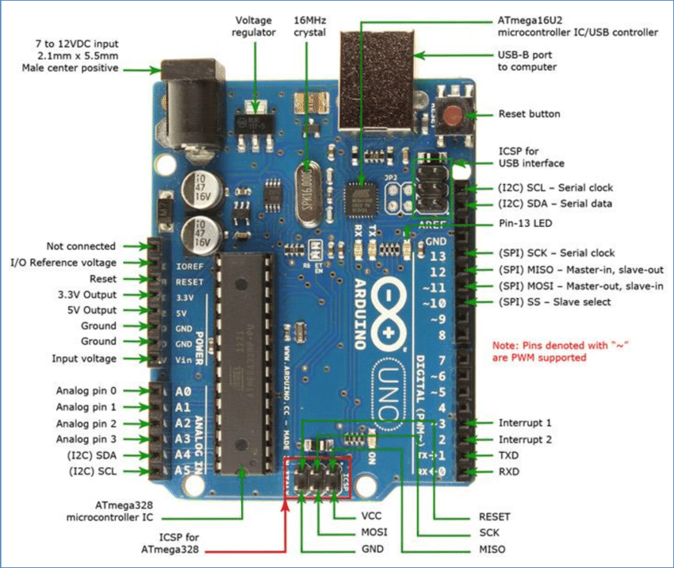
Fig 1. Arduino Uno
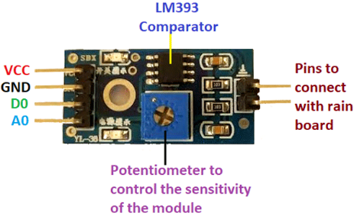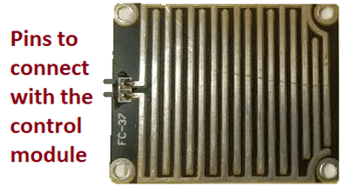
Fig 2. Rain Sensor Module Fig 3. Rain Sensor

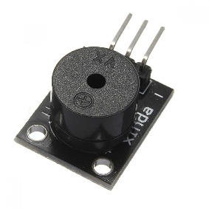
Fig 4. Buzzer

- Circuit Design and Schematic Creation: Before physical assembly, a detailed circuit diagram was conceptualized. This involved understanding the pinouts of each component (e.g., rain sensor's analog output, buzzer's control pin) and determining the appropriate Arduino pins for connection (e.g., analog input for the sensor, digital output for the buzzer). The design ensured correct power supply (VCC and GND) to all modules.

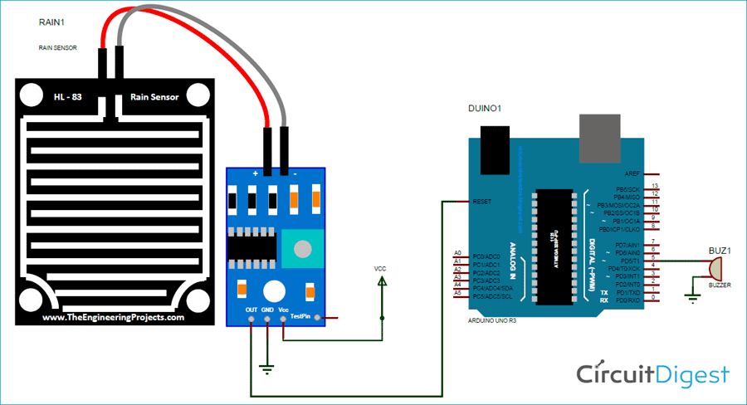

- Hardware Interfacing and Assembly: With the circuit design complete, the physical connections were made. The rain sensor's analog output (AO) pin was wired to an analog input pin (e.g., A0) on the Arduino. The rain sensor's power pins (VCC and GND) were connected to the Arduino's 5V and GND rails, respectively. The buzzer's signal pin was connected to a digital output pin (e.g., D8) on the Arduino, with its power also sourced from the Arduino's 5V and GND. All connections were carefully checked for continuity and correct polarity to prevent damage.

- Software Development (Arduino IDE): The core intelligence of the system resides in the Arduino program, written in the Arduino IDE (a C++ based environment). The programming sequence involved:
  - Initialization: Defining pin modes (input for sensor, output for buzzer) in the setup() function.
  - Sensor Data Acquisition: Continuously reading the analog voltage value from the rain sensor's analog output pin using analogRead(). This value typically ranges from 0 to 1023.
  - Data Processing and Thresholding: Implementing a crucial decision-making logic. The raw analog sensor value is inversely proportional to the amount of water detected (higher wetness means lower analog value). A specific threshold value was determined through experimentation (calibration). If the read sensor value falls below this calibrated threshold, it signifies the presence of rain.
  - Output Control: Based on the rain detection status, the digitalWrite() function was used to control the buzzer: HIGH to activate the buzzer (rain detected) and LOW to deactivate it (no rain).
  - Serial Monitor Feedback (for debugging): During development, serial communication was extensively used to print sensor readings and status messages, aiding in real-time debugging and understanding sensor behavior.

- Testing, Calibration, and Refinement: The assembled system was rigorously tested under various conditions. This involved applying controlled amounts of water (e.g., water droplets, light spray) to the rain sensor and observing the buzzer's response. The calibration process was iterative: the analog threshold value in the code was adjusted until the system accurately distinguished between dry conditions, minor moisture (like dew), and actual rainfall. This ensured optimal sensitivity and minimized false triggers. Any anomalies or inconsistencies observed during testing led to refinement of both hardware connections and software logic.

Chapter 7. Modules Identified
The proposed rainwater detection system is modular in design, composed of distinct yet interconnected electronic components, each performing a specific function. The primary modules are:
- Rain Sensor Module (YH-48/KY-09): This is the core sensing element of the system. It typically comprises two main parts:
  - Rain Board (Sensing Pad): This is a small printed circuit board (PCB) featuring exposed, parallel interdigitated copper tracks. The principle of operation relies on the electrical conductivity of water. In dry conditions, the resistance between these tracks is extremely high, approaching infinity. When rainwater falls onto the board, it bridges these tracks, creating conductive paths. The greater the amount of water, the lower the electrical resistance across these tracks. This change in resistance forms the basis of rain detection.
  - Control Board (Comparator Module): This board is equipped with an LM393 Dual Differential Comparator IC. Its main functions are:
    - Signal Conditioning: It takes the varying resistance output from the rain board and converts it into a more usable voltage signal.
    - Sensitivity Adjustment: It typically includes a potentiometer (variable resistor) that allows for manual adjustment of the sensitivity. This determines the threshold at which the comparator's output changes, effectively allowing fine-tuning of when the system considers the wetness to be "rain."

    - Analog Output (AO): Provides a continuous analog voltage signal proportional to the amount of wetness on the rain board. This output is read by the Arduino's Analog-to-Digital Converter (ADC). A common characteristic is that as wetness increases, the analog voltage decreases.
    - Digital Output (DO): The comparator also provides a binary digital output (HIGH or LOW). When the analog input crosses a threshold set by the potentiometer, the digital output switches state. This is useful for simple ON/OFF detection without needing an analog read. For this project, the analog output is preferred for more granular control.
- Arduino Microcontroller (e.g., Arduino Uno): This acts as the brain of the entire system.
  - Central Processing Unit (CPU): It executes the programmed instructions.
  - Analog-to-Digital Converter (ADC): The Arduino Uno has multiple analog input pins (A0-A5) with a 10-bit ADC. This allows it to read the analog voltage output from the rain sensor and convert it into a digital value (0-1023), which the microcontroller can then process.
  - Digital Input/Output (DIO) Pins: These pins are used to send control signals to output devices like the buzzer.
  - Power Supply: The Arduino board itself requires a power supply (e.g., via USB or a DC adapter) and can also provide regulated 5V and 3.3V power outputs to connected sensors and modules.
- Active Buzzer Module: This is the primary output module responsible for providing an audible alert.
  - Integrated Oscillator: Unlike a passive buzzer, an active buzzer has an internal oscillating circuit. This means it only requires a DC voltage to produce a continuous sound.
  - Simple Control: It typically has three pins: VCC, GND, and a signal pin. Applying a HIGH signal to the control pin (from the Arduino) activates the buzzer, and a LOW signal deactivates it. This simplicity makes it ideal for direct notification without complex waveform generation.

Chapter 8. Project Implementation
The successful implementation of the rainwater detection system involved a systematic approach to both hardware assembly and software development, ensuring reliable communication between components and accurate rain detection.

8.1. Hardware Setup and Interconnections

The physical assembly began with securely mounting the Arduino Uno board, the rain sensor module, and the active buzzer on a breadboard or prototype board for stability and ease of wiring. The electrical connections were made as follows:

- Rain Sensor to Arduino:
  - The VCC pin of the rain sensor's control board was connected to the 5V output pin of the Arduino Uno. This provides the necessary power to the sensor module.
  - The GND pin of the rain sensor's control board was connected to one of the GND pins on the Arduino Uno, establishing a common ground reference.
  - The Analog Output (AO) pin of the rain sensor's control board was connected to Analog Input Pin A0 on the Arduino Uno. This pin will be used by the Arduino's ADC to read the continuous analog voltage signal from the sensor, which varies with the amount of wetness.
- Buzzer to Arduino:
  - The VCC pin of the active buzzer module was connected to the 5V output pin of the Arduino.
  - The GND pin of the active buzzer module was connected to another GND pin on the Arduino.
  - The Signal pin of the active buzzer module was connected to a digital output pin, D8, on the Arduino Uno. This pin will be set to HIGH or LOW by the Arduino to turn the buzzer on or off, respectively.
All connections were made using jumper wires, ensuring firm contact and avoiding any short circuits.

8.2. Software Development and Programming (Arduino IDE)

The intelligence of the system is encapsulated in the Arduino program, developed using the Arduino IDE.
Code:

#define rainfall A0
#define buzzer 5
int value;
int set=10;
void setup() {
Serial.begin(9600);
pinMode(buzzer,OUTPUT);
pinMode(rainfall,INPUT);
}
void loop() {
value = analogRead(rainfall);
Serial.println("LOL");
Serial.println(value);
value = map(value,0,1023,225,0);
Serial.println(value);
if(value>=set){
Serial.println("rain detected");
digitalWrite(buzzer,HIGH);
}
else{
digitalWrite(buzzer,LOW);
}
delay(200);
}

8.3. Calibration and Testing
After uploading the code to the Arduino, thorough calibration was performed. This involved:
- Observing Dry State: Noting the rainValue when the sensor was completely dry (it should be high, close to 1023).
- Simulating Rain: Applying a few drops of water onto the rain board and observing how the rainValue dropped.
- Adjusting Threshold: Iteratively adjusting the rainThreshold in the code and/or the potentiometer on the rain sensor's control board until the buzzer reliably activated only when rain was present and deactivated when dry. For example, if dry reading was ~800-900 and wet reading ~100-300, a threshold like 500 or 600 would be appropriate.
- Functional Testing: Testing the system's response to various amounts of water, from light sprinkles to heavy drops, to ensure consistent and accurate detection.
This systematic implementation process ensured that the hardware and software worked in harmony, resulting in a reliable rain detection system.

Chapter 9. Findings / Results of Analysis

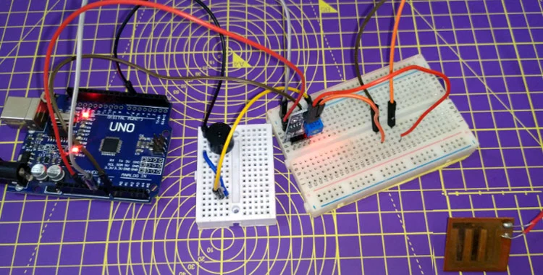
The implementation and subsequent testing of the rainwater detection system yielded positive and conclusive results, affirming its operational effectiveness. The system demonstrated its ability to reliably detect the presence of water on the rain sensor's conductive surface, accurately interpreting this as a rainfall event.

Key Findings:
- Accurate Sensor Response: The rain sensor module consistently exhibited a predictable change in its analog output voltage in response to varying degrees of wetness. As water accumulated on the interdigitated copper tracks, the electrical resistance decreased, causing the analog output voltage (read by Arduino's A0 pin) to drop proportionally. This inverse relationship between wetness and analog voltage was fundamental to the detection process. For instance, in a dry state, the sensor's analog reading would typically be high (e.g., 700-900 on a 0-1023 scale), while upon contact with water, it would significantly drop (e.g., to 100-300).
- Reliable Threshold-Based Detection: Through careful calibration and adjustment of the rainThreshold in the Arduino code (and optionally the potentiometer on the sensor's control board), the system effectively distinguished between minor ambient moisture (e.g., high humidity, condensation) and actual precipitation. This robust thresholding ensured that the system only triggered for genuine rain events, minimizing false positives that could otherwise lead to unnecessary alerts.
- Instantaneous Audible Alert: Upon the detection of rain (i.e., when the sensor's analog reading fell below the predetermined threshold), the active buzzer activated almost instantaneously. This provided a clear, immediate, and unambiguous audible notification of rainfall. The promptness of the alert is crucial for applications requiring rapid response.

- System Stability: The integrated hardware and software components demonstrated good stability during continuous operation. There were no observed instances of erratic behavior, unexpected shutdowns, or significant drifts in sensor readings under consistent conditions.
- Simplicity and Cost-Effectiveness: The project successfully demonstrated that a functional rain detection system can be built using relatively inexpensive and readily available components, making it a highly cost-effective solution for basic environmental monitoring and automation.
In summary, the analysis confirms that the implemented Arduino-based rainwater detection system fulfills its core objective of reliably identifying rain and providing a timely alert. The system's performance underscores the practical utility of integrating simple sensors with microcontrollers for effective real-world applications.

Chapter 11. Conclusions

This mini-project successfully achieved its objectives by designing, implementing, and thoroughly testing a functional and remarkably cost-effective rainwater detection system. Leveraging the versatility of the Arduino microcontroller in conjunction with a dedicated rain sensor module, the system proficiently detects the presence of rainfall and provides an immediate, unmistakable audible alert via an active buzzer.
The project served as an invaluable exercise in understanding fundamental concepts of embedded systems, sensor interfacing, and basic automation principles. It clearly demonstrated how analog sensor data can be acquired, processed through software logic, and translated into tangible outputs. The system's simplicity in design belies its effectiveness and reliability in providing real-time notification of precipitation.
Ultimately, this project stands as a robust proof-of-concept. While a basic alert system, its successful implementation lays a strong foundational understanding for more complex and sophisticated environmental monitoring and smart automation applications. It validates the potential of accessible technology to solve practical everyday problems and enhances our interaction with environmental conditions.

Chapter 12. Project Limitations and Future Enhancements
While the current iteration of the rainwater detection system effectively achieves its primary goal, several limitations were identified during its development and testing. These limitations, however, also serve as clear pathways for future enhancements, paving the way for more sophisticated and versatile systems.

Project Limitations
- Single Point Detection and Lack of Spatial Data: The most significant limitation is that the system provides rain detection only at the precise physical location of the sensor. It offers no information regarding the spatial distribution of rainfall across a wider area or the direction from which rain is coming. This restricts its applicability for larger-scale agricultural fields or complex urban environments where localized data is crucial.
- Absence of Rainfall Intensity Measurement: The current system provides a binary "rain/no-rain" output. It does not quantify the intensity or volume of rainfall. This means it cannot differentiate between a light drizzle and a heavy downpour, which is critical information for applications like smart irrigation (where irrigation might be skipped only if sufficient rain falls) or flood prediction.
- Sensor Durability and Maintenance Concerns: The exposed copper tracks on the rain board are susceptible to corrosion and oxidation over extended periods of outdoor exposure, particularly in harsh weather conditions or areas with polluted air. This degradation can lead to inaccuracies in readings over time, necessitating periodic cleaning or replacement of the sensor. Additionally, dust, dirt, or debris accumulating on the sensor surface can also interfere with accurate detection.
- Potential for False Positives/Negatives: While calibration helps, the system is still susceptible to false positives from extreme humidity, condensation, or persistent dew, which might trigger the sensor even without actual rain. Conversely, very fine mist or extremely light precipitation might not form large enough water bridges on the sensor to reliably trigger detection, leading to false negatives.
- No Data Logging or Historical Analysis: The current setup provides only real-time alerts. It does not store any historical data regarding when rain occurred, for how long, or how frequently. This limits its utility for long-term environmental monitoring, climatological studies, or performance analysis of automated systems.
- Limited Output and Non-Remote Notification: The sole output is an audible buzzer, which is effective only within its direct audible range. There are no visual indicators (like LEDs or an LCD) or remote notification capabilities (e.g., SMS, email, mobile app push notifications), which would be crucial for unattended operations or alerts over long distances.
- Power Dependency: The system requires a continuous power supply (e.g., USB, wall adapter). It is not optimized for low-power consumption, making it less suitable for long-term, battery-operated, or remote deployments without external power sources.

Future Enhancements

Based on the identified limitations, several avenues exist for significantly enhancing the capabilities and utility of this rainwater detection system:
- Integration with Internet of Things (IoT): A paramount enhancement would be to incorporate Wi-Fi (e.g., ESP8266/ESP32 modules) or LoRaWAN communication capabilities. This would enable the system to send real-time rain detection alerts, sensor data, and potentially historical logs to a cloud platform (e.g., ThingSpeak, Firebase). Users could then monitor rain status remotely via a web dashboard or a dedicated mobile application, receiving push notifications or email alerts.
- Rainfall Intensity Measurement: To move beyond binary detection, integrating a more sophisticated sensor, such as a tipping bucket rain gauge, would allow for precise measurement of rainfall intensity and accumulation (e.g., mm/hour). This data could be logged and analyzed for agricultural planning or storm water management.
- Automated Actuation and Smart Home Integration: The most impactful enhancement would be to integrate relays or smart switches that can be controlled by the Arduino. This would enable the system to perform automated actions upon rain detection, such as:
  - Closing windows or skylights in smart homes.
  - Activating/deactivating irrigation pumps in smart gardens or farms.
  - Retracting awnings or sunshades.
  - Triggering vehicle windshield wipers (in experimental setups). This could be integrated with existing smart home ecosystems (e.g., Home Assistant, Google Home).
- Advanced Output and User Interface:
  - Adding an LCD display (e.g., 16x2 I2C LCD) to show real-time sensor values, rain status, and potentially historical summaries.
  - Implementing RGB LEDs to provide clear visual cues (e.g., green for dry, red for rain, blue for high humidity).
  - Integrating a passive buzzer or speaker for more complex audible patterns or melodies, rather than just a continuous tone.
- Enhanced Sensor Durability and Accuracy:
  - Exploring alternative sensor designs or materials (e.g., nickel plating, non-corrosive conductive polymers) for improved longevity in outdoor environments.
  - Implementing self-cleaning mechanisms (e.g., small vibrations, hydrophobic coatings) to prevent dust and debris accumulation.
  - Using multiple sensors placed strategically to provide more localized data and potentially identify the direction of rain.

- Power Management and Solar Integration: For remote or off-grid deployments, implementing low-power design techniques (e.g., Arduino sleep modes) and integrating a small solar panel with a battery charging circuit would make the system self-sustainable.
- Artificial Intelligence/Machine Learning (AI/ML) for Predictive Analysis: For long-term data collection, applying simple AI/ML algorithms could potentially predict rain events based on historical patterns, humidity levels, and pressure changes, moving from reactive detection to proactive forecasting.
These enhancements would transform the basic rain detector into a comprehensive, intelligent environmental monitoring and control system, unlocking its full potential across various applications.

References
- CircuitDigest. (n.d.). Rain Detector using Arduino. Retrieved from https://circuitdigest.com/microcontroller-projects/rain-detector-using-arduino

- Chhetri, S. B., & Bhandari, P. (2018). Design and Implementation of an Automated Irrigation System using Arduino. International Journal of Engineering Research & Technology (IJERT), 7(03), 190-193.
- Relevance: While primarily about irrigation, many automated irrigation systems integrate rain detection as a crucial component. This paper would likely discuss the use of rain sensors for intelligent water management.

- Kumar, M. P., Lakshmi, T. S. V., & Divya, N. (2017). Automated Rain Sensing Wiper System for Vehicles using Arduino. International Journal of Pure and Applied Mathematics, 114(10), 303-311.
- Relevance: Directly addresses an application of rain detection (windshield wipers) using Arduino, which is a strong parallel to your project's core technology.

- Patel, P., Panchal, S., Dave, H., & Rathod, M. (2016). Smart Weather Monitoring System Using Arduino. International Journal for Research in Applied Science & Engineering Technology (IJRASET), 4(VII), 45-50.
- Relevance: A broader weather monitoring system often includes rain detection. This paper might offer insights into integrating various environmental sensors, including rain sensors, with Arduino.

- Bhatt, A., Chauhan, J., & Thakker, D. (2015). Design and Implementation of Automatic Rain Sensing Wiper Control System. International Journal of Engineering Research and General Science, 3(4), 1133-1137.
- Relevance: Another paper focusing on the automotive application of rain sensing, which provides practical examples and potential circuit designs for rain detection.

- Sharma, D., Singh, Y., Singh, P., & Singh, R. (2017). IoT Based Smart Irrigation System Using Arduino and Rain Sensor. International Journal of Scientific Research in Science and Technology (IJSRST), 3(3), 856-861.
- Relevance: Combines rain sensing with IoT and Arduino for an agricultural application, showing how a simple rain detector can be part of a larger smart system.

